**LIT TRAINING**

**Batch Name : SAP ABAP ON HANA** **DAY 15 ASSIGNMENT**

**EMPLOYEE ID – 46255260**

Assignment 1 – Create a Simple program to fetch data and display ALV using Std. SAP class-methods.

CODE:

REPORT z46255244lit_alv1.

TABLES:SNWD_PD.

DATA: it_fieldcat  TYPE slis_t_fieldcat_alv,

      wa_fieldcat  TYPE slis_fieldcat_alv,

      GROUP TYPE STRING.

SELECT CATEGORY,

       MAX( PRICE ) AS MAX_PRICE,

       AVG( PRICE ) AS AVG_PRICE,

       CASE

       WHEN length( category ) <=  8 THEN 'LOW LENGTH CATEGORY'

       WHEN length( category ) >  8 THEN 'HIGH LENGTH CATEGORY'

       END AS GROUP

       FROM SNWD_PD AS A GROUP BY CATEGORY having LENGTH( CATEGORY ) > 4 INTO TABLE @DATA(IT_OUT).

  wa_fieldcat-fieldname  = 'CATEGORY'.

  wa_fieldcat-seltext_m  = 'CATEGORY'.

  APPEND wa_fieldcat TO it_fieldcat.

  wa_fieldcat-fieldname  = 'MAX_PRICE'.

  wa_fieldcat-seltext_m  = 'MAX_PRICE'.

  APPEND wa_fieldcat TO it_fieldcat.

  wa_fieldcat-fieldname  = 'AVG_PRICE'.

  wa_fieldcat-seltext_m  = 'AVG_PRICE'.

  APPEND wa_fieldcat TO it_fieldcat.

  wa_fieldcat-fieldname  = 'GROUP'.

  wa_fieldcat-seltext_m  = 'CATEGORY_GROUP'.

  APPEND wa_fieldcat TO it_fieldcat.

  CALL FUNCTION 'REUSE_ALV_GRID_DISPLAY'

    EXPORTING

      it_fieldcat   = it_fieldcat

    TABLES

      t_outtab      = IT_OUT

    EXCEPTIONS

      program_error = 1

      OTHERS        = 2.

OUTPUT:

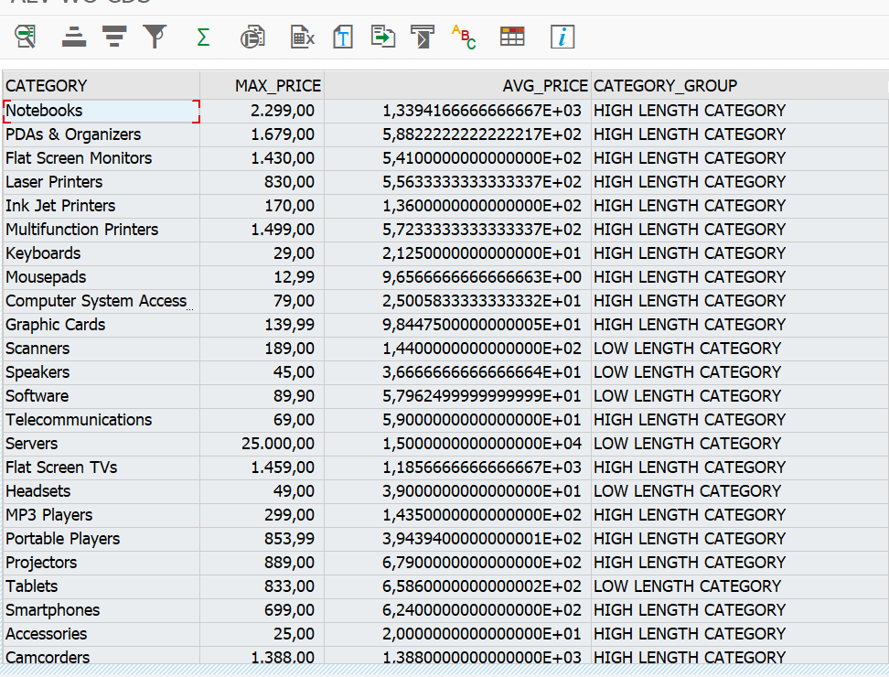

Assignment 2 – ALV with IDA

CDS VIEW

CODE:

@AbapCatalog.sqlViewName: 'Z_CDS_ALV'

@AbapCatalog.compiler.compareFilter: true

@AbapCatalog.preserveKey: true

@AccessControl.authorizationCheck: #NOT_REQUIRED

@EndUserText.label: 'CDS VIEW ALV'

**define** **view** Z46255244LIT_CDS_ALV **as** **select** **from** vbak **as** B

**left** **outer** **join** vbap **as** A

**on** A**.**vbeln **=** B**.**vbeln **{**

    B**.**vbeln **as** SOrder**,**

    A**.**posnr **as** Sales_doc_item**,**

    B**.**vkorg **as** SOrganization**,**

    A**.**matnr **as** Material_Num**,**

    A**.**zmeng **as** TotalQuantity

**}**

**CODE:**

REPORT z46255244lit_alv.

TABLES:VBAP, VBAK.

data: posnr type vbap-posnr.

SELECT-OPTIONS: S_matnr FOR vbap-matnr.

try.

CL_SALV_GUI_TABLE_IDA=>create_for_cds_view(

  EXPORTING

    iv_cds_view_name               = 'Z46255244LIT_CDS_ALV'

  RECEIVING

    ro_alv_gui_table_ida           = DATA(O_OUT)

).

CATCH cx_salv_db_connection.

CATCH cx_salv_db_table_not_supported.

CATCH cx_salv_ida_contract_violation.

CATCH cx_salv_function_not_supported.

ENDTRY.

DATA(O_IN) = NEW CL_SALV_RANGE_TAB_COLLECTOR( ).

O_IN->add_ranges_for_name(

  EXPORTING

    iv_name   = 'matnr'

    it_ranges = S_matnr[]

).

O_IN->get_collected_ranges(

  IMPORTING

    et_named_ranges = DATA(OUT)

).

try.

O_OUT->set_select_options(

  EXPORTING

    it_ranges                     = OUT

).

CATCH cx_salv_ida_associate_invalid.

CATCH cx_salv_db_connection.

CATCH cx_salv_ida_condition_invalid.

CATCH cx_salv_ida_unknown_name.

ENDTRY.

o_out->display_options( )->enable_alternating_row_pattern( ).

o_out->display_options( )->set_title( iv_title = 'ALV report with IDA, CDS consumption' ).

o_out->toolbar( )->hide_all_standard_functions( ).

O_OUT->fullscreen( )->display( ).

**OUTPUT:**

